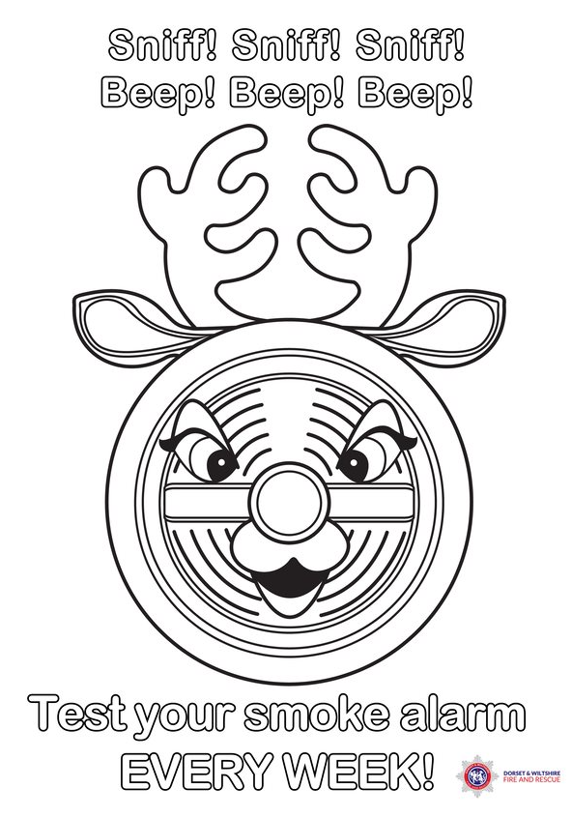
For more fun activities for children please visit www.dwfire.org.uk/education
Keep you and your family safe this Christmas by:
- Check you have working smoke alarms
- Check fire escape routes are clear of trip hazards
- Check everyone (including guests) knows what to do if there is a fire
- Switch off Christmas/ fairy lights when you go to bed or go out
- Check decorative lights are in good condition
- Check you are not overloading extension leads
- Make sure candles are in proper holders, in safe locations and blow out when there is not an adult in the room.
- If using a real fire, make sure the chimney is swept (this also helps Father Christmas)
- Do not leave cooking unattended
Wishing you a safe and wonderful Christmas period from everyone at
Dorset and Wiltshire Fire and Rescue Service

